Connected Vehicle Intelligence Hackathon
ValeoSense
Solution Document
Synthetic telemetry • live fleet state • historical intelligence
Problem space chosen: Fleet operations, unsafe-driving incident detection and idling analysis.
To be submitted by: TEAM ACTION — enter your official team name.
Team members & roles: TEAM ACTION — list each member’s name, role and email address.
Repository URL: https://github.com/Kaileshwar16/VeloSense
Repository URL comes from the local origin remote; reviewer access and latest remote contents have not been verified.
Demo video URL (≤ 5 minutes): TEAM ACTION — add an accessible recording link.
Date of submission: TEAM ACTION — enter the actual submission date (DD/MM/YYYY).
Document prepared: 01/10/2026. Source revision: c5549e8.
Submission format: PDF exported from this editable Word document.
Evidence boundary
Technical sections use repository source, saved artifacts and verification records dated 27–30 September 2026, cross-checked against the supplied 10-page Motorq Hackathon Problem Statement. This document preparation did not rerun the application or benchmarks. “Done” means implemented with stated local evidence; it does not mean production qualified. The PDF’s full production-quality bar is not met. Yellow TEAM ACTION text identifies items the submitting team must finalize.
Readiness: technical narrative completed; team details, final video/timestamps, final repository/tag checks and unresolved evidence gaps remain.

Table of Contents
1. Executive Summary
2. Problem Statement & Validation
3. Solution Description
4. Feature List
5. Solution Architecture (High-Level Design)
6. Low-Level Design
7. Non-Functional Requirements & Performance Benchmarks
8. Security & Compliance
9. Test Strategy
10. Observability
11. AI / ML Component (if used)
12. Architecture Decisions, Risks & Future Enhancements
13. Demo Video (5 Minutes Maximum)
14. Repository Checklist
15. Conclusion
16. Declarations
17. Appendix (if any)
Subsections 2.1–2.3, 3.1–3.3, 5.1–5.4 and 6.1–6.5 follow the supplied template. Supporting commands and evidence paths are included in section 17.

1. Executive Summary
ValeoSense helps fleet managers inspect current vehicle conditions, detect operational incidents and investigate recent history while telemetry continues to arrive. The prototype separates Redis live state, PostgreSQL metadata and ClickHouse analytical history behind a FastAPI service and React dashboard. A deterministic registry contains 100,000 synthetic vehicles; the normal demonstration activates a 1,000-vehicle subset.
Stateful JSON telemetry flows through Kafka-compatible Redpanda to a bounded Python processor. Detectors identify prolonged idling, speeding, harsh braking/acceleration, diagnostic faults and low energy. Existing external QueryFlux software routes history queries to ClickHouse and small recent-sample queries to embedded DuckDB. Optional Prometheus/Grafana monitoring and an independent Iceberg raw archive support inspection and replay-oriented investigation.
The saved 15-second benchmark generated 999.87 readings/sec at the stable 1K target, with 923.99 consumed records/sec including startup and drain. A 10K target was unstable. One measured ClickHouse optimization reduced median execution from 23.693 ms to 2.402 ms and rows read from 515,271 to 4,096. The 30 September verification record reports 106 Python tests passed and three opt-in integration tests skipped, plus separate real archive integration checks. No sustained 100K events/sec, customer savings or availability SLA is claimed.

2. Problem Statement & Validation

2.1 Problem Statement
A fleet manager needs a way to detect current incidents and inspect vehicle history because continuously arriving telemetry and historical scans have different access needs. Unnoticed idling, unsafe manoeuvres and diagnostic faults can delay operational intervention; the real financial and safety cost has not been measured in this project.
Primary user: fleet manager. Secondary stakeholders: dispatch/operations staff, maintenance teams and drivers. The prototype tests engineering feasibility using synthetic telemetry; it does not validate customer demand through interviews or field deployment.

2.2 Evidence & Validation
Evidence / assumption | Source or method | What it shows | Confidence
100,000 unique vehicles and VINs | artifacts/registry-verification.json; seeded CSV generator | Verified registry size; active subset is separately configured. | High for synthetic registry
Duplicate and sink replay handling | tests/integration/test_stack.py; docs/verification.md | Tested Kafka/API path and deduplicated analytical reads. | High for tested paths
Capacity boundary | benchmark_results.json; two 15-second stages | 1K generation target stable; 10K unstable. | Medium; short duration
Two analytical engines execute | artifacts/dual-engine-lineage.json | Three seeded IDs found via both routes; native counters advanced. | High for saved run
Idling fuel cost | Settings assumption: 0.8 L/h × INR 100/L for ICE | INR 80 per engine-on idle hour; EV fuel cost excluded. | Assumption only
Business benefit / customer pain | No field study, interviews or customer dataset | No measured savings, incident reduction or comparative advantage. | Unvalidated

Alternatives include OEM portals, aftermarket telematics devices and integrated fleet tools such as Motorq Fuse. They were not trialled or benchmarked here. The demonstrated design choice is workload separation and traceable engine execution; no unsupported claim that existing products lack these capabilities is made.

2.3 Impact & Success Metrics
Metric | Baseline / observed | Target | Measurement
Registry correctness | 100,000 rows; 100,000 unique IDs/VINs | Exactly 100,000 deterministic records | Saved registry validation
Processing capacity | Stable short 1K generation target | Template: 100K+ events/sec | Real broker + processor + both sinks; target unmet
Vehicle history lookup | 23.693 ms median before | Reduce scan work | 2.402 ms median after; five runs each
Dashboard / alert latency | 3-second polling; no percentiles | <2 s dashboard; <5 s critical alert | End-to-end latency study pending
Operational impact | No customer baseline | Measure actionable incidents and avoidable idle time in a pilot | Simulation demonstrates mechanics only

Scale of impact: at one event per active vehicle per second, 10K active vehicles require 10K events/sec and 100K active vehicles require 100K/sec; neither is demonstrated as stable here. A 100K-row registry is not equivalent to 100K concurrently emitting vehicles. Potential benefits are faster investigation and visibility into idle time; avoided fuel, emissions, crashes or breakdowns have not been measured.

3. Solution Description

3.1 Solution Overview & User Journey
1. Start the configured Compose stack and authenticate on the dashboard. 2. Inspect fleet count, advancing vehicle timestamps and live incidents. 3. Open a vehicle to read its current state and ClickHouse history. 4. Inspect idling estimates and aggregate activity. 5. Run a bounded recent-sample query through DuckDB and inspect engine evidence. 6. Use incident context to decide on an operational follow-up; the system does not control vehicles or send driver commands.
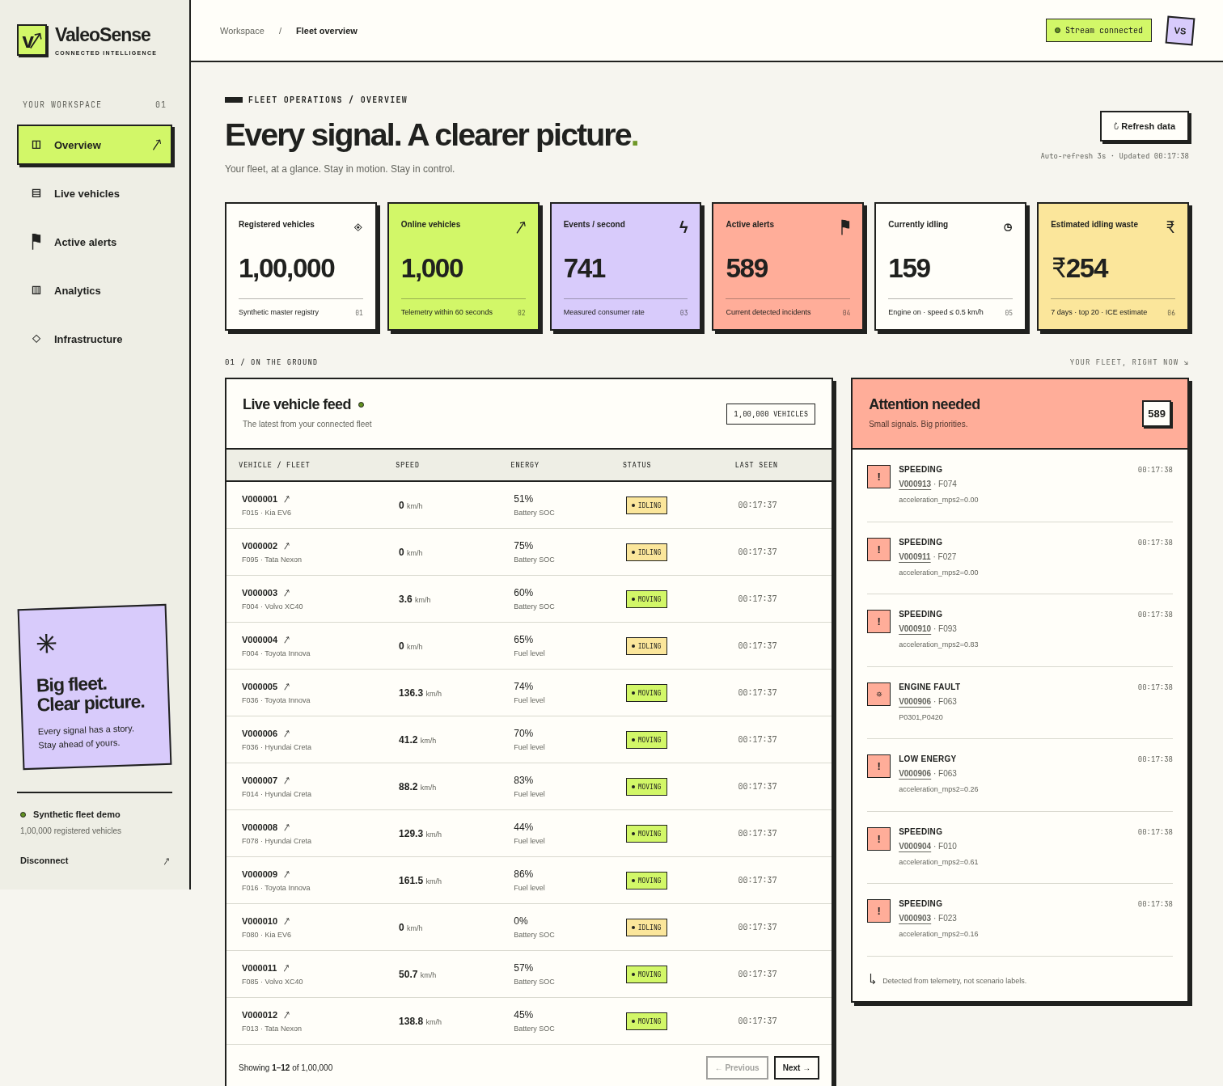
Figure 1. Working product screenshot from saved Chromium verification (September 2026), top excerpt. Displayed counts and rates are point-in-time observations, not benchmark results.

3.2 Key Value Proposition
Customer job: understand which vehicles need attention and retrieve relevant history. Pain relieved: live reads use Redis independently of analytical admission, while relational metadata and history have dedicated stores. Gain: the operator sees live state, deterministic incident context, historical records and bounded sample scope in one interface. Differentiation demonstrated by this prototype is transparent data lineage and explicit route evidence; competitive superiority has not been validated.

3.3 Innovative Ideas
Technique | Implementation and proof | Scope
Separate live and analytical access | Redis live reads; ClickHouse history; independent UI polling; analytical semaphore. | Established architecture applied to the demo.
Traceable two-engine analytics | ClickHouse → bounded Parquet → DuckDB; seeded IDs and native engine counters in dual-engine-lineage.json. | Explicit namespace routing, not automatic cost optimization.
Recoverable raw archive | Optional Iceberg data + next-offset checkpoint in one catalog transaction; raw malformed records retained. | Local archive tests; no S3 qualification or ClickHouse backfill.

4. Feature List
MoSCoW status: Done indicates implementation plus the stated saved local checks. Planned items are not provided by the prototype. TEAM ACTION — replace every “Pending” video cell for Done features with an actual timestamp from the final recording; the template asks for video evidence for each Done feature.
ID / Feature | User story | Priority | Status | Code path | Video
F-01 Synthetic fleet + 12 scenarios | As an evaluator, reproduce realistic stateful inputs. | Must | Done | simulator/; scripts/generate_vehicles.py | Pending
F-02 Incident detectors | As an operator, spot idling, unsafe manoeuvres, faults and low energy. | Must | Done | processor/detectors.py | Pending
F-03 Dedup + late-event handling | As an operator, avoid repeated incidents and stale live state. | Must | Done | processor/pipeline.py; consumer.py | Pending
F-04 Live / metadata / history APIs | As a manager, retrieve bounded authenticated fleet data. | Must | Done | backend/main.py; shared/storage.py | Pending
F-05 Dashboard + history | As a manager, inspect incidents and vehicle context. | Must | Done | frontend/src/main.jsx; api.js | Pending
F-06 QueryFlux two-engine route | As an analyst, query history or a disclosed recent sample. | Should | Done | backend/analytics.py; backend/queryflux/; scripts/duckdb_snapshot.py | Pending
F-07 Prometheus / Grafana | As an operator, inspect lag, throughput and engine metrics. | Could | Done | backend/monitoring.py; infra/monitoring/ | Pending
F-08 Iceberg raw archive | As an operator, preserve raw records and read snapshots. | Could | Done | archive/; tests/unit/test_iceberg.py | Pending
F-09 Multi-tenant identity / HA | As a production owner, isolate fleets and survive node loss. | Won’t in prototype | Planned | No implementation | N/A

5. Solution Architecture (High-Level Design)

5.1 Architecture Overview
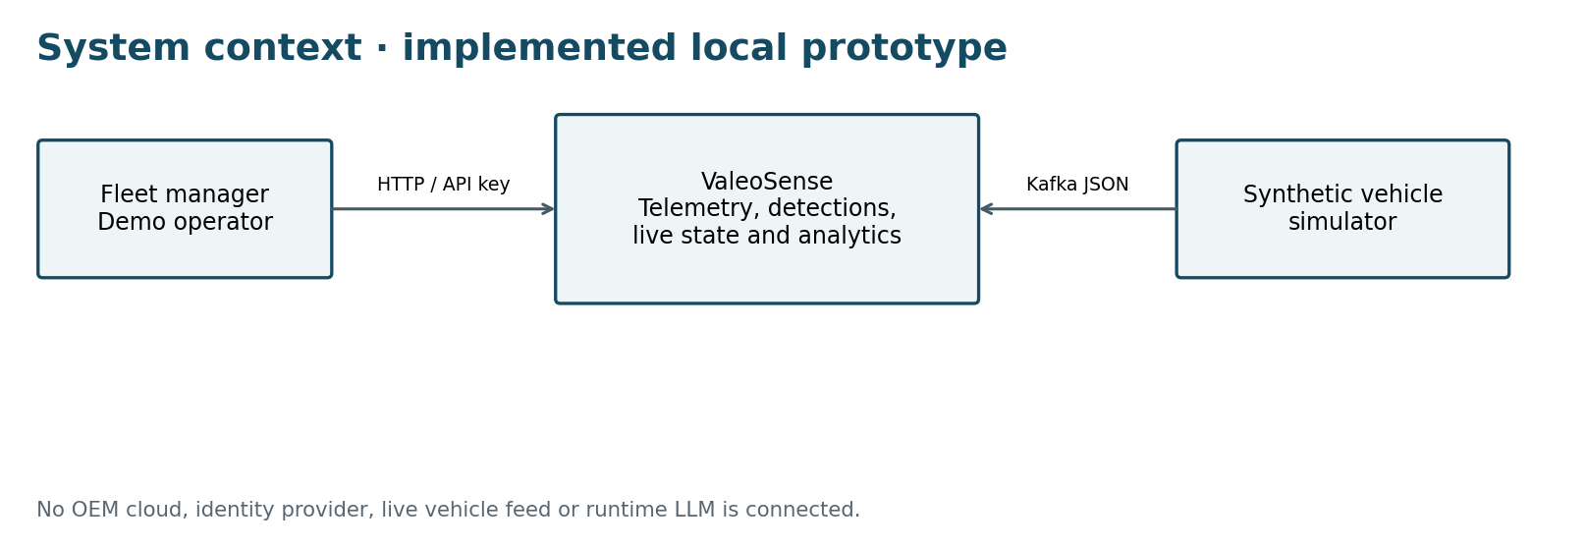
Figure 2. C4-style context: one local system, one operator and synthetic vehicle input.
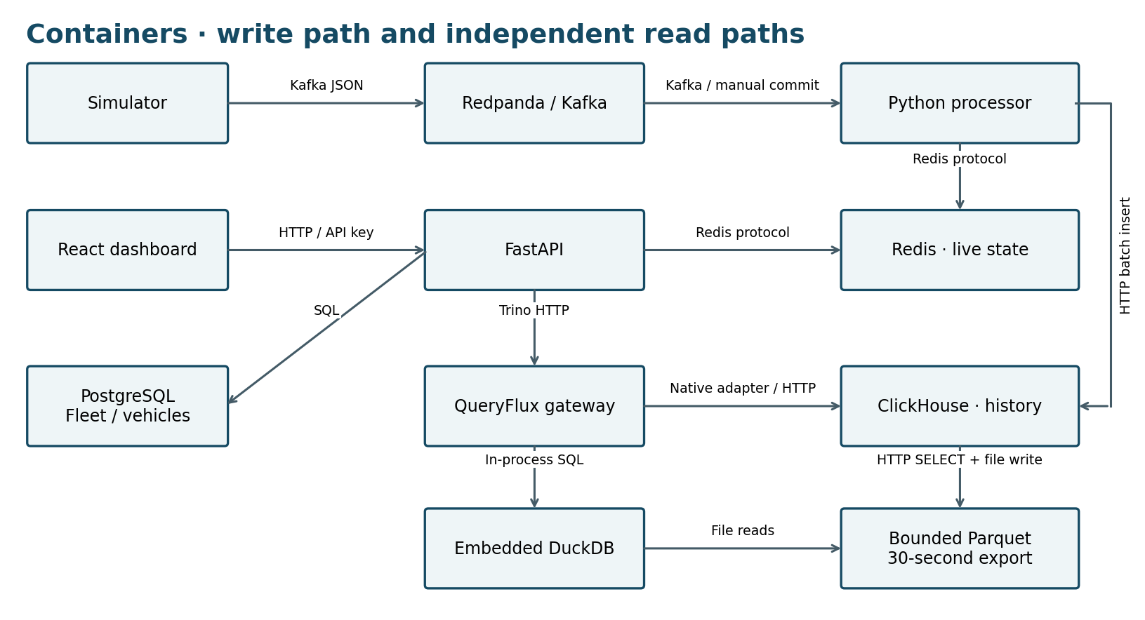
Figure 3. Core service/data-store view. Arrows identify protocols or file access; direct ClickHouse mode is an explicit alternative API configuration.
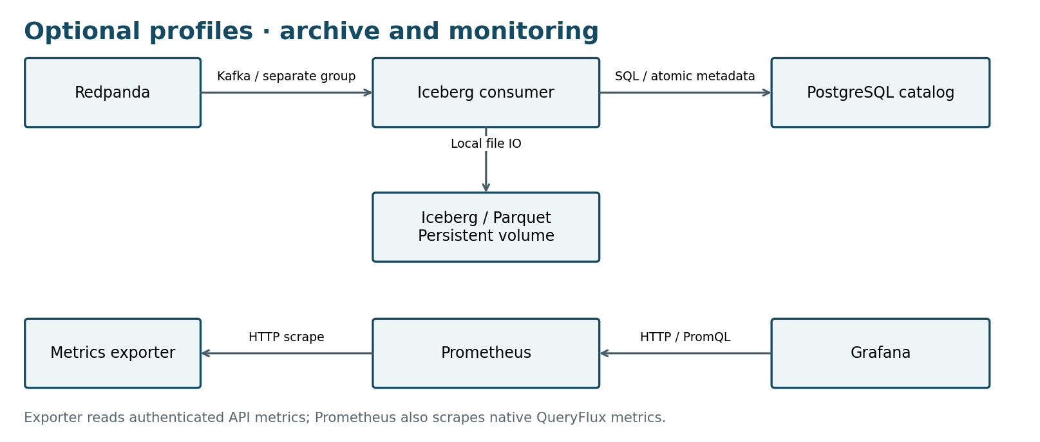
Figure 4. Optional archive and monitoring profiles. Archive progress is independent of live processing.
Hop | Mechanism / configured bound | Latency evidence
Simulator → Kafka | vehicle_id key; six partitions; producer linger 20 ms | Configured batching, not measured hop latency
Kafka → processor | Manual commits; up to 500 messages per batch | No per-hop percentile distribution
Processor → history/live | ClickHouse insert then Redis transaction, then offset commit | Latest-batch latency gauge; not a percentile
Stores → operator | API request; independent UI polling every 3 seconds | <2-second dashboard target not established
History → DuckDB sample | Refresh every 30 s; reject snapshot older than 120 s | Bounded sample, not instantaneous full history

5.2 Technology Stack & Justification
Layer | Choice | Why / alternatives and trade-offs
Ingestion / messaging | Redpanda, Kafka protocol | Partition ordering and replay instead of direct synchronous writes; one broker reduces demo overhead but lacks HA.
Processing | Python, Pydantic, bounded batches | Small testable processor instead of introducing Flink/Spark; single owner limits scale.
Live / metadata / history | Redis; PostgreSQL; ClickHouse | Point reads, relational constraints and columnar scans separated instead of forcing every workload into one store.
Analytics / archive | Existing QueryFlux; DuckDB; optional PyIceberg | Explicit engine routes and bounded sample; archive independently preserves raw Kafka identity.
Backend / frontend | FastAPI; React/Vite | Typed request validation, OpenAPI and independently refreshing panels; polling chosen over a WebSocket service.
ML / AI | Deterministic threshold rules | Explainable baseline; no trained model or LLM in runtime.
Infrastructure / CI / observability | Docker Compose; GitHub Actions; optional Prometheus/Grafana | Reproducible local services; Kubernetes and multi-cloud deployment deferred.

5.3 Data Architecture
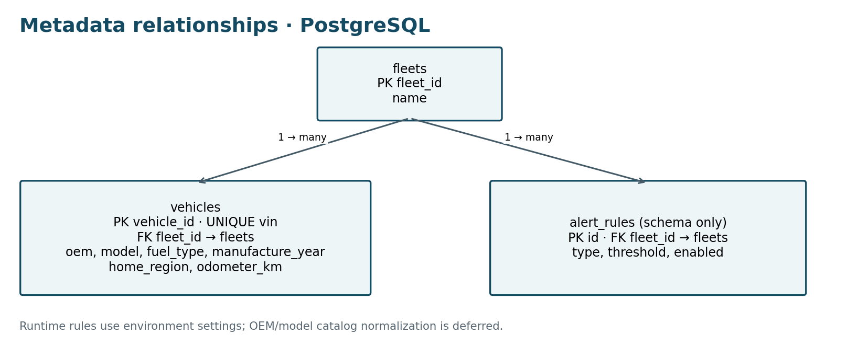
Figure 5. Implemented metadata ER view (infra/postgres.sql). Full OEM/model catalog normalization is deferred.
Normalization: fleets and vehicles are separated with foreign keys and a unique VIN constraint. OEM/model/fuel attributes deliberately repeat per vehicle; full catalog 3NF is not claimed. ClickHouse repeats fleet/vehicle attributes to avoid metadata joins in telemetry scans. alert_rules is a schema placeholder; detector rules currently come from environment settings.
Store / tier | Data and retention | Consistency / partition trade-off
Redpanda buffer | 6 partitions, 1 replica; 24 h or 256 MiB per partition, whichever limit applies | Single broker; no multi-node CP/AP guarantee established.
Redis hot state | Latest state/alerts: 1 h; dedup: 24 h; 256 MiB noeviction | Processing fails closed on sink/lease failure; favors stopping over uncertain progress.
PostgreSQL metadata/catalog | Fleets, vehicles; optional Iceberg SQL catalog | Single transactional authority; unavailable if this node fails.
ClickHouse warm history | Monthly partitions; (vehicle_id, timestamp, event_id) ordering; 30-day TTL | ReplacingMergeTree + FINAL dedup views; no atomic transaction with Redis.
DuckDB sample | ≤120 min, first 100 vehicle IDs, ≤20,000 rows; 30 s refresh; max age 120 s | Derived snapshot; stale sample returns 503 rather than a successful stale answer.
Iceberg cold archive | Daily received_at partitions; raw bytes and Kafka coordinates; no automatic TTL | Data and next-offset properties commit atomically; one advisory-lock owner. No cross-store transaction.

CAP labels depend on deployment and failure conditions. This single-node prototype does not demonstrate partition-tolerant multi-node CP or AP behavior. It explicitly stops live processing when sinks cannot acknowledge and rejects stale DuckDB samples, sacrificing availability in those tested paths.
PACELC: without a partition, direct Redis reads favor low live-read latency while ClickHouse FINAL applies deduplication work at query time; DuckDB trades freshness/completeness for a bounded local sample. During failures, required sink acknowledgements and sample freshness checks take priority over continued successful responses. This explains local consistency/latency choices; replication latency and multi-node partition behavior have not been measured. Storage cost is not priced: no cloud region, service size or verified pricing basis is selected, so the byte estimates below are not a monetary cost estimate.
Capacity estimate uses an assumed decimal 1 KB/event before compression, replicas, indexes and metadata. Required rate = active vehicles × readings/second. These are planning calculations, not measured disk usage:
Event rate | Daily volume | Yearly volume (365 days) | Validation
1K/sec | 86.4 GB | 31.536 TB | Short generation target stable
10K/sec | 864 GB | 315.36 TB | Short run unstable
100K/sec | 8.64 TB | 3.1536 PB | Not attempted

Partition keys: Kafka uses vehicle_id; ClickHouse uses monthly event-time partitions and a vehicle/time/event ordering key; Iceberg uses daily received_at partitions, preserving event time separately. Archive coverage begins at retained Kafka offsets. It cannot recover already expired records or historical ClickHouse-only data.
Query | Before (ms) | After (ms) | Change / evidence
Vehicle history, latest 100 rows | 23.693 | 2.402 | substring(vehicle_id, 2) → exact vehicle_id equality; 515,271 → 4,096 rows read.
Fleet idling aggregation | Not measured | Not measured | Evidence gap: save real before/after plans, equal results and timings.
Event activity aggregation | Not measured | Not measured | Evidence gap: save real before/after plans, equal results and timings.

One of the requested three comparisons exists. Recorded evidence is ClickHouse EXPLAIN indexes = 1 plus five actual execution statistics per variant, not an EXPLAIN ANALYZE report. The equality predicate changes primary-key pruning from 474/474 to 4/474 granules; results match. Full plans and runs: docs/sql-optimization.md and artifacts/sql-optimization.json. The submitting team should confirm acceptance of this engine-specific equivalent and add two genuine comparisons.

5.4 Deployment View
One development host / Docker Compose network
Browser → 127.0.0.1:3000 (frontend proxy) → backend:8000
One broker + one processor + one Redis + one PostgreSQL + one ClickHouse
QueryFlux + DuckDB bootstrap / snapshot worker (root demo)
Optional: monitoring profile; iceberg profile
Persistent Docker volumes: databases, snapshots and archive files
Ignored .env: generated local credentials / configuration
Root docker compose up --build -d starts the configured two-engine demo and simulator after setup. Published service ports bind to loopback. Services use one replica, health checks and restart policies; no Kubernetes namespace, autoscaler, load balancer or cloud-managed secret store is configured. The same images/Compose definitions can be moved to another suitable host, but no second-cloud deployment has been tested. Availability remains tied to one machine and its volumes.
PDF requirements, pages 6 and 9–10: a deployment on at least one cloud, portability to another without code changes, Helm charts or Kubernetes manifests, and Terraform for one cloud. These artifacts and a verified cloud deployment are absent. Dockerfiles and Compose alone do not complete that DevOps pack.

6. Low-Level Design

6.1 Layering & Separation of Concerns
The implementation is a pragmatic layered service design. Detectors are independently testable, but SQL templates remain in API handlers and the processor knows its sink adapters; strict hexagonal dependency inversion is not claimed.
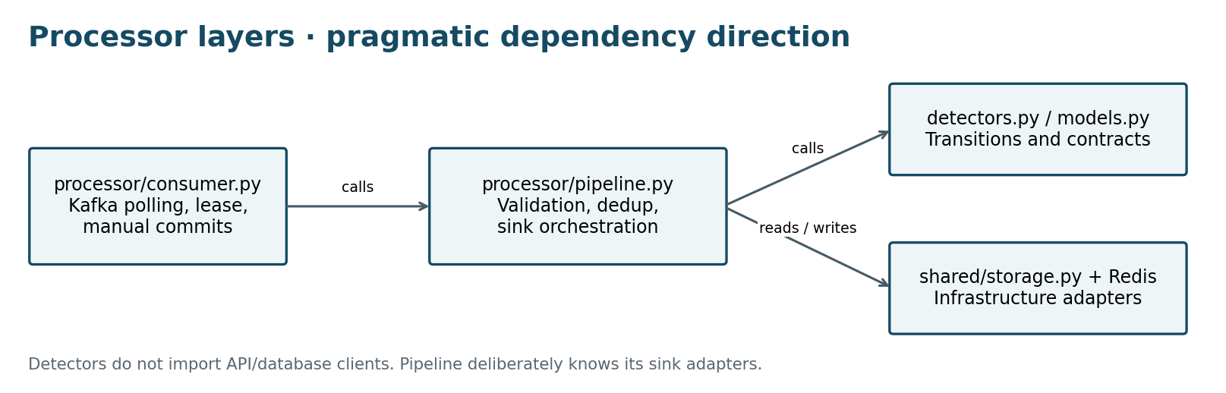
Figure 6. Allowed call direction in the processor and the explicit infrastructure coupling.
Layer | Responsibility / code | Boundary / current exception
Presentation / API | React UI; FastAPI validation, API key, DTOs | UI contains no database clients; backend/main.py currently also contains SQL templates.
Application / service | Processor sequencing; analytics route selection and admission | Orchestrates adapters; depends on concrete Redis/ClickHouse clients in this prototype.
Domain | shared/models.py; processor/detectors.py | Typed event constraints and incident transitions; no HTTP/DB client calls.
Infrastructure | shared/storage.py; Kafka producer/consumer; archive/catalog clients | Encapsulates external IO; no claim of full vendor-type isolation.

simulator/ cli.py, generator.py, producer.py, vehicle_factory.py
processor/ consumer.py, pipeline.py, detectors.py
shared/ models.py, config.py, storage.py
backend/ main.py, analytics.py, monitoring.py, queryflux/
archive/ cli.py, consumer.py, table.py, config.py
frontend/ src/, scripts/, package.json
infra/ docker-compose.yml, postgres.sql, clickhouse.sql, monitoring/
scripts/ setup_env.py, benchmark.py, duckdb_snapshot.py, verify_dual_engine.py
tests/ unit/, integration/
docs/ architecture.md, verification.md, adr/, iceberg.md
artifacts/ saved JSON reports, logs and product screenshots

6.2 Design Principles Applied
SOLID: detector transition logic has one focused responsibility; storage and QueryFlux clients have narrow interfaces, and tests inject doubles into Processor/create_app. Dependency inversion is partial because production orchestration still constructs concrete clients. Settings, canonical models and shared adapters reduce repeated logic (DRY); explicit thresholds and bounded batches keep the design understandable (KISS).
12-factor practices: environment configuration, separate worker/API processes, pinned dependency locks and container logs. State is external to application processes; graceful producer flush and manual offset commits support disposability. Local persistent volumes and bootstrap jobs are development deployment choices, not full cloud-native qualification.
Idempotency: deterministic event/alert keys, in-batch sets, Redis SET NX with TTL and ClickHouse FINAL views. Fail-fast: invalid settings, lost lease, sink failure, untrusted gateway nextUri and stale samples return explicit failures. Least privilege is partial: API-key checks, loopback ports and unprivileged application containers exist; tenant roles and separate read-only analytical credentials remain work.

6.3 Design Patterns Used
Pattern | Problem solved | Code
Adapter | Wrap database and analytical gateway operations | shared/storage.py; backend/queryflux/client.py
CQRS-style workload separation | Use distinct live/metadata/analytical read paths | backend/main.py; processor/pipeline.py
Explicit strategy / routing | Select direct vs QueryFlux mode and sample namespace | backend/analytics.py; infra/queryflux.yaml
Bulkhead / bounded admission | Limit analytics to four running and sixteen waiting requests | backend/analytics.py
Idempotent consumer / checkpoint | Replay protection; atomic archive offsets with data | processor/pipeline.py; archive/consumer.py

No saga, transactional outbox, distributed exactly-once transaction or dedicated circuit breaker is implemented. Retry/restart behavior is bounded by producer/client settings and worker failure semantics.

6.4 Interfaces, Contracts & Runtime Flows
Contract | Implemented behavior
OpenAPI / version | http://localhost:8000/openapi.json and /docs; endpoints under /api/v1
Authentication | X-API-Key; constant-time comparison; no OIDC/RBAC
Pagination / bounds | Vehicles: limit 1–100 and offset ≥0; history: 1–30 days, limit ≤1,000; validated vehicle/fleet IDs
Error envelope | {"error":{"code":503,"message":"A required data service is unavailable"}}; validation errors use 422 with field locations
Admission / rate limits | Four concurrent analytical requests, sixteen waiting; bounded query templates; no general per-user request rate limiter
Event topic / key | valeosense.telemetry.v1; key vehicle_id; JSON validated by shared/models.py
Schema / evolution | schema_version=1; UTC timestamp; UUID event_id; extra fields rejected; no schema registry or migration pipeline

Canonical events include vehicle/VIN/fleet identity, event time, sequence, latitude/longitude, speed/heading, engine state, fuel or SOC, odometer, engine temperature, DTC list, event_type, source_oem and schema_version. Exactly one of fuel_pct/soc_pct is populated. Unknown formats are rejected by the live processor; the optional archive preserves invalid raw payloads with an error classification.
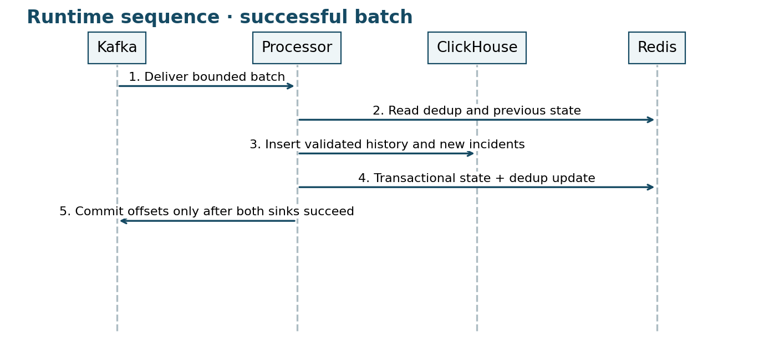
Figure 7. Successful processing. Domain validation and detector transitions occur before inserts.
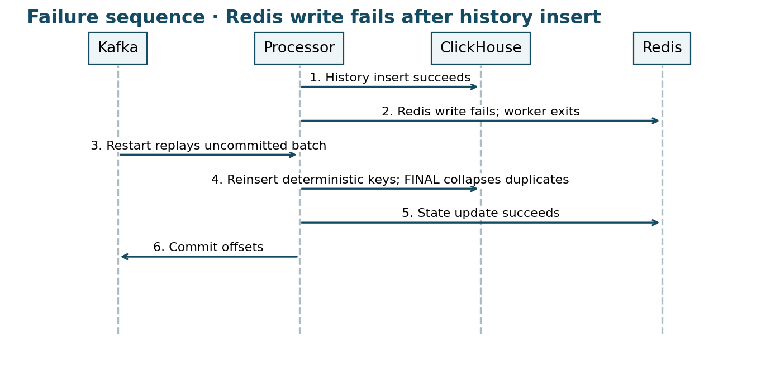
Figure 8. Tested recovery pattern. Practical replay protection does not make Redis and ClickHouse one atomic transaction.

6.5 Algorithms & Data Structures
Detectors use previous per-vehicle state and episode state. Idle means engine on and speed ≤0.5 km/h; continuity resets after a gap over ten seconds. The default idle alert requires more than 20 seconds. Acceleration = Δspeed / 3.6 / Δtime; harsh defaults are below −3 or above +3 m/s², and speeding is above 100 km/h. Faults inspect DTC contents. Episodes suppress repeated new incidents while active alerts update.
for payload in bounded_batch: # O(B)
validate canonical schema and event time
skip event IDs already in in_batch_set # expected O(1)
read dedup markers and previous state from Redis
for event in valid_events:
if retained dedup marker exists: continue
if event is late: append history only
else: compute transition; append history + new incidents
insert ClickHouse history / incidents
commit Redis state + dedup markers # sorted sets O(log V)
commit Kafka offsets only after both sinks acknowledge
Time: expected O(B) validation/hash/scalar transition work for batch size B, plus O(B log V) sorted-set updates for V active vehicles and network/storage costs. Space: O(B) batch buffers, O(V) live state and O(event rate × dedup TTL) retained markers. DTC lists are capped at sixteen. The benchmark exercised 1K and 10K active vehicles with the recorded generation rates; no isolated per-function runtime or 100K/sec processing claim is made.

7. Non-Functional Requirements & Performance Benchmarks
NFR | Template target | Achieved / gap | How measured
Ingest throughput | Sustain 100K+ events/sec | Not achieved. Stable short 1K target; 10K unstable. | 15 s real pipeline stages; benchmark_results.json
Burst tolerance | 3× burst for 5 minutes without loss | Not tested at 300K/sec; simulator burst behavior alone is insufficient | PDF page 9; no qualifying load report
Horizontal scalability | Add service/broker nodes without code changes | Partial service boundaries; processor and archive enforce one owner | No scale-out demonstration
End-to-end latency | <2 s dashboard; <5 s critical alert | Not established. UI polls every 3 s. | No event-to-visible percentile benchmark
API latency | p95 <200 ms; p99 <500 ms | Not measured | Single query observations and means are not percentiles
Resilience | Recover after broker/pod failure | Tested duplicate/sink replay and stale-sample recovery; broker crash campaign absent | Integration checks and docs/verification.md
Availability | 99.9%; no single point of failure | Not provided: one host, one broker and one state owner | Architecture/configuration inspection

Load setup: scripts/benchmark.py runs the real generator → Kafka → processor → Redis + ClickHouse path. The saved host had eight logical CPUs and 7,988,129,792 bytes RAM (about 8 GB). Each requested stage lasted 15 seconds, optional monitoring was enabled, and no concurrent demo simulator was allowed. Passing requires ≥90% generation target, exact published/consumed counts, the same processor instance, <5 seconds drain and no processor errors.
Target | Generated/sec | Consumed/sec incl. startup/drain | Drain | Status
1,000/sec | 999.87 | 923.99 | 0.50 s | Stable short stage
10,000/sec | 9,997.86 | 3,762.36 | 24.53 s | Unstable
25K / 50K / 100K | Not attempted | Not attempted | N/A | Stopped after saturation

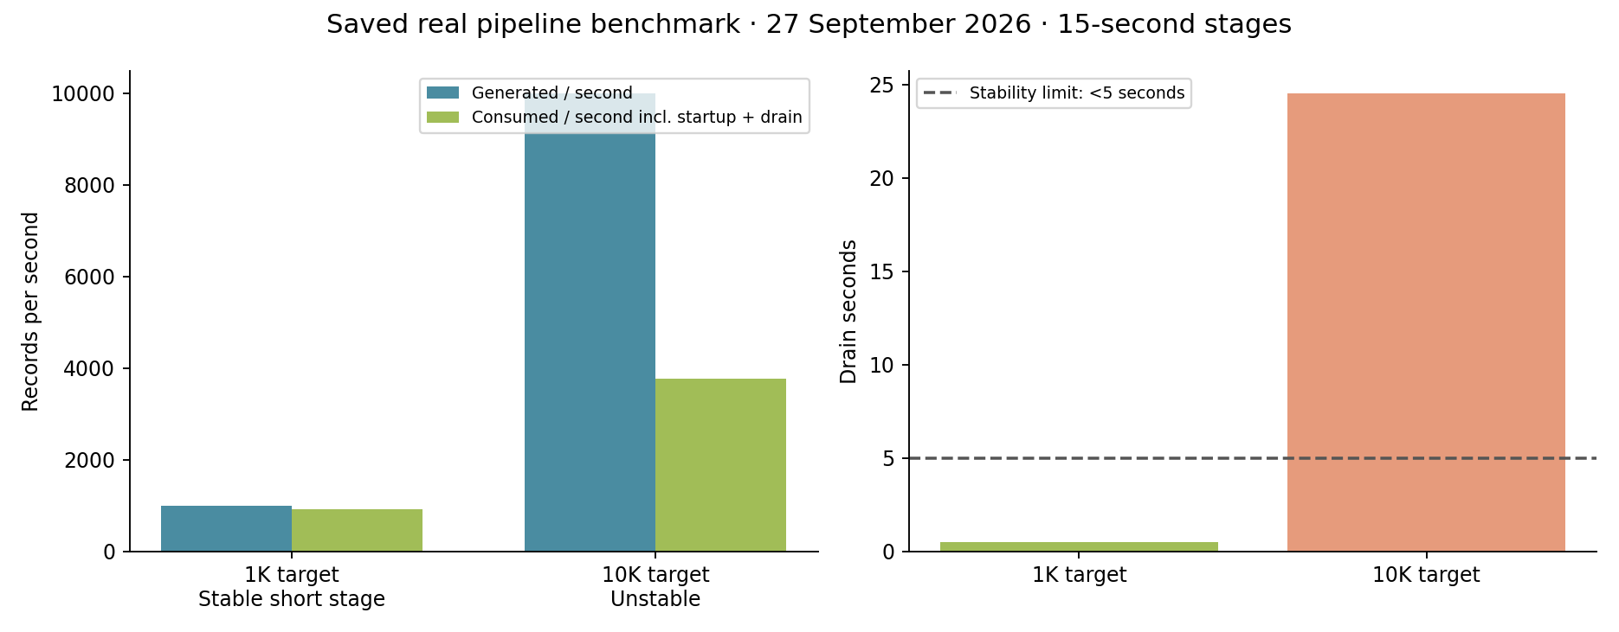
Figure 9. Chart generated from benchmark_results.json; measured 27 September 2026. Intentional duplicate/malformed scenarios make generated, published, accepted and consumed counts distinct.
At the 1K stage, 15,000 readings were generated, 15,270 records published and consumed, 14,925 accepted, 270 duplicates ignored and 75 schema errors rejected. At 10K, 152,595 records were published and consumed after the long drain. These short stages are not a soak test. API p95/p99, a full end-to-end latency distribution and sustained 100K/sec remain evidence gaps.

8. Security & Compliance
Threat / STRIDE category | Implemented controls | Remaining limitation
Forged or modified telemetry (S/T) | Loopback broker access, canonical schema, numeric bounds and event-time validation | No producer identity, payload signatures or mTLS
Unauthenticated or cross-fleet access (S/I/E) | API key, constant-time comparison and bounded validated identifiers | Single demo operator; no tenant isolation, OIDC or RBAC
SQL injection (T/E) | Parameterized metadata SQL, fixed analytical templates, no arbitrary SQL endpoint | Separate read-only analytical credentials not implemented
Secret / location disclosure (I) | Ignored locally generated credentials, loopback ports, synthetic locations | No service TLS, managed secrets or verified at-rest encryption
Exhaustion / replay / provenance (D/R) | Bounded queues/admission, dedup, event IDs, offsets and logs | Finite dedup TTL; no immutable audit log or broad rate limiter

Authentication and authorization: protected API routes use a static local key; the frontend stores the key for the browser session. CORS allows configured origins and is not authentication. /health and /docs expose health/schema without a key. QueryFlux uses configured credentials; Grafana requires login. Device identity, tenant isolation, fleet-level authorization and service-to-service authentication are incomplete.
Privacy: vehicle IDs, VINs, telemetry and locations are synthetic. No real driver records are intentionally used. Live state expires after one hour, ClickHouse history after 30 days and Kafka by configured time/size limits. The optional Iceberg archive has no automatic expiry; deletion/retention maintenance and a complete erasure workflow are not implemented. No GDPR/DPDP compliance assessment or certification is claimed.
AI safety: not applicable to runtime because there is no LLM or autonomous agent in the processing path. Security scan coverage and a complete transitive SBOM remain missing evidence. This section reports implementation state, not a legal or security certification. Source: docs/threat-model.md.
The PDF page 9 goes further than local API-key protection: it requires OAuth2/OIDC + JWT, RBAC/tenant isolation, device mTLS, TLS 1.3, AES-256 at rest, secrets in a vault, OWASP Top 10/API Top 10 controls, audit logs for each data access, location masking and verified erasure. These are missing or unverified. Existing operational logs are not a per-access audit trail; synthetic data avoids real-person exposure but does not implement the requested privacy workflows.

9. Test Strategy
Test type | Tools | Count / saved result | Coverage / limitations | In CI?
Unit / API / component | pytest, doubles, temporary Iceberg tables | 106 passed; 3 opt-in integrations skipped (30 Sep) | Includes 14 archive component cases; line/branch coverage not measured | Yes; hosted run not checked here
Integration / contract | Real Kafka, Redis, PostgreSQL, ClickHouse, QueryFlux | 2 core/dual-engine cases passed (28 Sep UTC); 1 archive case passed on host and in container (30 Sep) | Separate runs; do not add repeated host/container execution as distinct tests | No; opt-in
Acceptance / browser | Node request tests, Playwright, Chromium smoke | 3 request + 4 Playwright tests passed; browser smoke passed | Saved two-engine verification; no formal BDD feature suite | No
Performance / load / soak | Custom Python benchmark; ClickHouse plans | 2 load stages; 1 optimization comparison | 1K stable, 10K unstable; no soak or p95/p99 report | No
Security SAST/DAST/dependencies/images | No saved scanner campaign | Not run / no report | Ruff is lint, not a complete security scan | No
Compliance / chaos | Replay and fault-oriented tests | Targeted paths verified; no separate campaign count | No broker-cluster chaos, compliance certification or HA qualification | Partial unit cases only

Edge cases covered by code/tests include repeated events, late timestamps, non-finite/out-of-bounds values, invalid DTCs, mutually exclusive fuel/SOC, long continuity gaps, producer delivery failure, sink failure, cancelled analytical waiters, untrusted pagination origins, stale/missing metrics, archive tombstones, uncertain catalog responses and failed Kafka acknowledgements. Unknown OEM formats are schema failures, not an implemented OEM adaptation layer.
Illustrative input/output contract: for consecutive valid engine-on readings at 0 km/h, the first interval beyond the configured 20-second idle threshold creates an IDLING_ALERT; repeating the same event ID does not create another incident while dedup state is retained. This is a contract example, not an additional measured experiment.
Report locations: docs/verification.md, artifacts/browser-smoke.json, artifacts/dual-engine-lineage.json, artifacts/monitoring-smoke.json, benchmark_results.json and artifacts/sql-optimization.json. Some archive results are recorded in the verification narrative rather than a committed standalone raw test log. The current CI workflow runs Ruff, pytest and the frontend build; external integration/browser/security checks require additional jobs or explicit disclosure.
PDF pages 9–10 specifically require ≥80% coverage on core services/algorithms, BDD acceptance scenarios, real-service integration/contract evidence, a soak test, SAST/DAST/dependency/image scans, audit/erasure tests, broker/pod kill recovery and a CI pipeline link. No coverage report, formal BDD suite, consumer-driven contract suite, soak/security campaign, erasure test or broker-kill recovery report is present. Candidate pipeline URL: https://github.com/Kaileshwar16/VeloSense/actions (inferred from origin; successful final run and reviewer access must be checked).

10. Observability
The API exposes request/error counts, workload counts, process heartbeat, generator/consumer rate, committed lag and analytical route information. Optional exporter → Prometheus → Grafana collects operational history; Prometheus separately scrapes native QueryFlux engine counters and duration metrics. API route labels identify intended workloads; native counters provide independent execution evidence.
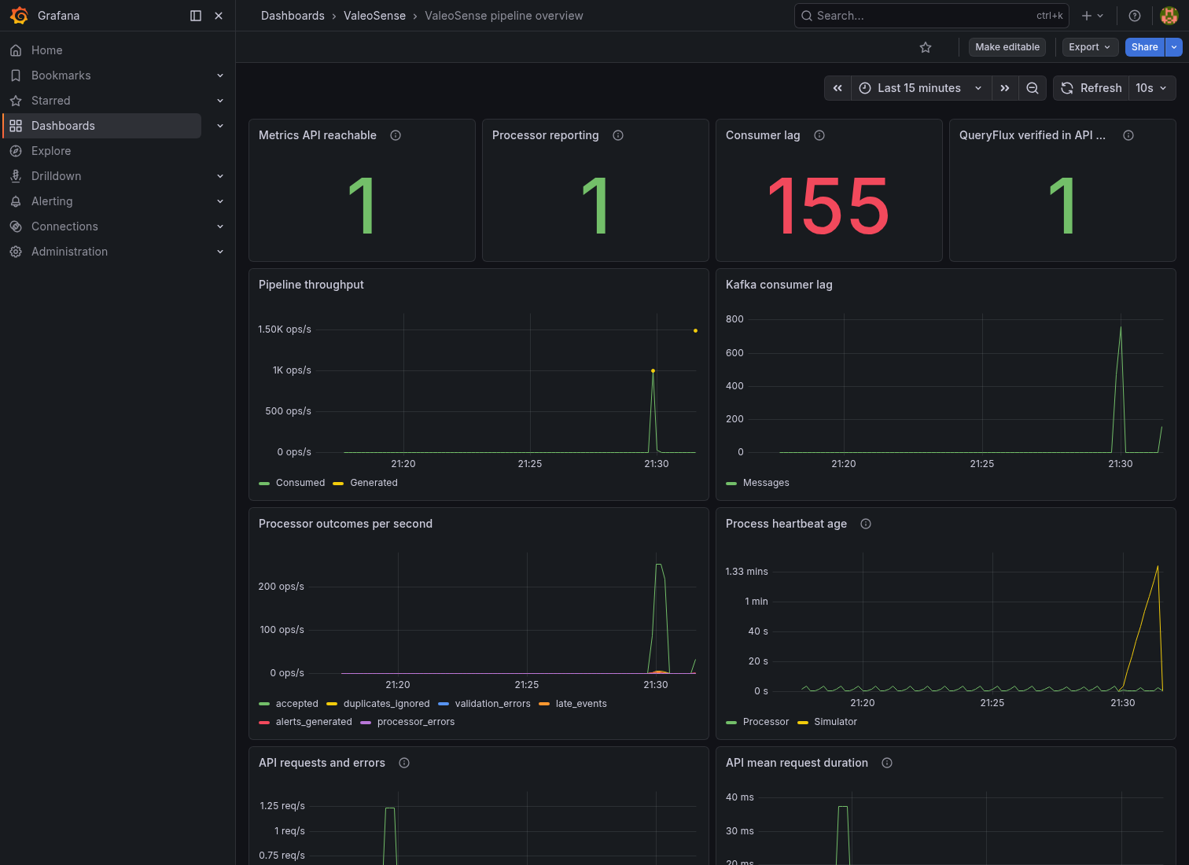
Figure 10. Saved Grafana screenshot showing throughput, lag, outcomes and heartbeat. This earlier capture is evidence of rendering; the later verification record reports 18 panels. No current health claim is inferred from the screenshot.
Troubleshooting a latency spike: (1) check scrape health, processor heartbeat and fresh vehicle timestamps; (2) compare producer and consumer rates with committed lag; (3) inspect processor logs and Redis memory, especially the 256 MiB noeviction limit; (4) compare ClickHouse/QueryFlux errors and query-duration observations; (5) check snapshot age if only DuckDB requests fail; (6) rerun the bounded verification after the fault is resolved. A healthy /health response alone does not prove fresh telemetry.
Prometheus scrapes every ten seconds and has bounded local retention. Counters are process-local. API mean duration and latest-batch event latency are not p95/p99. Distributed traces, a tracing UI and outbound alert notifications are not implemented; the missing end-to-end latency percentiles remain a requirement gap.
PDF page 7 also calls for centralized logs, metrics and traces. Metrics are implemented in the optional profile; logs remain local/container logs and there is no central log backend or distributed tracing. This expectation is only partially met.

11. AI / ML Component (if used)
Not applicable: the runtime uses deterministic rules and per-vehicle episode state, with no trained ML model, vector store, retrieval pipeline or LLM agent. Explicit thresholds are sufficient for the prototype’s observable incident definitions; predictive maintenance accuracy is not claimed.
Data/features: synthetic physical telemetry, prior event state, elapsed time and diagnostic codes. Model evaluation, leakage checks, hallucination controls, per-request LLM costs and tool-access policies do not apply to this implementation. Codex assisted engineering and documentation; it is not part of the production event path. Any future predictive model would require labelled evaluation data and comparison against these rules before claiming benefit.
Scope ambiguity to resolve: PDF page 6 says vector storage is needed “where useful”; pages 7–8 nevertheless list an ML/vector layer, an agent with guardrails/audit and combined vector storage among technical expectations. No such component is implemented. TEAM ACTION — confirm whether the chosen deterministic, non-AI problem scope is accepted; if not, this is an additional implementation requirement, not a completed feature. Graph/DP algorithms and specific opportunity examples should likewise be selected only where relevant to the chosen problem.

12. Architecture Decisions, Risks & Future Enhancements
ADR / context | Options → decision | Consequences
001: ordered replayable ingestion | Direct writes / Kafka / Redpanda → one Redpanda broker, six partitions | Simple Kafka-compatible demo; no replication-based HA.
002: live state and continuity | Relational-only / process memory / Redis → Redis with TTL and lease | Restartable hot state; finite memory; on failure stop rather than commit uncertain work.
003: metadata vs event history | One general store / specialized stores → PostgreSQL + ClickHouse | Constraints plus analytical scans; cross-sink transaction absent.
004: analytical route | Direct ClickHouse / external gateway → QueryFlux with native history and bounded DuckDB sample | Externally attributed dependency; explicit rules, no cost-based routing/failover.
005: bounded demo scope | Large orchestrated stack / minimal local services → Compose and optional profiles | Local Iceberg/monitoring possible; cloud, maintenance and HA qualification deferred.

CAP-related choice: ADR-002 deliberately stops ingestion when Redis cannot maintain trustworthy state/ownership; ADR-004 rejects stale samples. This is an availability trade-off in known failure paths, not proof of cluster-wide CP behavior. Full decision records: docs/adr/001-streaming.md through 005-scope-and-retention.md.
Known risks: one state owner; finite broker retention; Redis dedup memory growth; no Redis/ClickHouse atomic transaction; malformed live records lack a dedicated dead-letter queue; no user/tenant authorization; short benchmark evidence; incomplete query comparisons/security scans; local archive growth without compaction/expiry. Archive verification explicitly excluded a pre-existing restarting live processor, so that record alone cannot establish current dashboard health.
Next three steps toward a pilot: (1) strengthen recovery with partition-owned workers, tested checkpoints, capacity/latency soak tests and failure drills; (2) implement authenticated tenant boundaries, producer identity, encrypted transport and measured security controls; (3) qualify durable archive storage and backup/restore, compaction and retention, then run a small fleet pilot with validated business metrics.

13. Demo Video (5 Minutes Maximum)
TEAM ACTION — record and upload the final working-product demo, no longer than 5:00, at 1080p with clear audio; captions are recommended. Supply the accessible URL here and on the cover, then replace feature-table Pending cells with actual timestamps. The following times are a proposed storyboard, not claims about an existing video.
Time | Segment | What to show
0:00–0:30 | Problem | Fleet manager need; 100,000 registered synthetic vehicles; distinguish active subset.
0:30–1:00 | Solution | Architecture and separate live/history read paths.
1:00–3:00 | Live demo | Advancing telemetry, an actual detected incident, vehicle history, bounded DuckDB sample and native route evidence.
3:00–4:15 | Under the hood | Recorded replay integration result, benchmark limits and one real SQL optimization; optional monitoring.
4:15–5:00 | Impact / next steps / team | Measured engineering results, unvalidated business impact, next steps and team.

Video link: TEAM ACTION — insert final YouTube/Vimeo/Drive URL with reviewer access.
Detailed click-by-click preparation and narration are already in docs/demo-recording-guide.md (target 4:50). Rehearse on fresh telemetry and verify both native engines before recording. Keep API keys and local credentials off-screen. An integration replay clip proves its stated duplicate/sink-replay path; it does not prove broker-cluster failover or exactly-once cross-store transactions.

14. Repository Checklist
Requirement | Current status | Remaining action
README and startup | README, environment example, diagrams, run guide and commands present | Fresh-clone rehearsal; confirm reviewer can reproduce setup.
One-command configured run | docker compose up --build -d starts root demo after setup | Initial setup downloads dependencies/images; running stack not refreshed during document edit.
Service / docs / infra / tests structure | Present; source revision c5549e8 | Keep final code and submission artifacts consistent.
CI build, lint, all tests, security | Ruff, pytest and frontend build configured | Integration/browser/security suites not included; add or explicitly disclose.
Secrets / .env.example / contributions | .env ignored; example present; generated secrets local | Review final tracked files, attribution and authentic member contributions; no history scan claimed.
Repository URL / access | origin: https://github.com/Kaileshwar16/VeloSense | Verify final remote code, permissions and reproducibility.
Final tag v1.0-submission | Absent from local tag list on 1 Oct | Create on reviewed final commit and push when ready.
Final PDF / video | Document draft and PDF preview prepared; no video supplied | Finalize highlighted fields, refresh PDF and submit the actual package.

TEAM ACTION — finalize team metadata, video and timestamps, review the technical gaps, verify repository access and the final tag, then export the completed Word document to PDF. This edit did not stage files, commit, push, upload a video or submit to the organizer.

15. Conclusion
ValeoSense demonstrates a complete synthetic event-to-dashboard path with bounded processing, incident detection, independent live and analytical stores, explicit two-engine lineage and an optional raw archive. The strongest evidence is reproducible local behavior: deterministic registry checks, real service integration, replay tests and measured query pruning.
Key learnings are that fleet registry size differs from streaming capacity, deduplicated views do not create cross-store exactly-once transactions, and configured routes need native execution evidence. Timestamp/late-event handling, stale sample failure behavior and processor saturation were tested or documented. Moving to a pilot requires stronger recovery, tenant security, operational maintenance and sustained performance evidence; customer impact remains to be validated.

16. Declarations
External component attribution: QueryFlux is an existing external project (https://github.com/lakeops-org/queryflux), not software created for this submission. The project integrates it through configuration and clients. The following are declared licenses recorded in docs/open-source.md from the 27–30 September checks; this is not a full transitive SBOM or a new legal audit.
Component | Declared license / qualification
QueryFlux; ClickHouse | Apache-2.0; existing external components.
DuckDB / libduckdb-sys | MIT; local libduckdb-sys 1.10501.0 LICENSE and package metadata inspected for this document.
Redpanda v25.1.9 | BSL-1.1 source-available; not classified as permissive open source.
Redis server 7.4 | RSALv2 or SSPLv1; distinct from redis-py MIT client.
PostgreSQL 17 | PostgreSQL license.
PyIceberg / pyiceberg-core / PyArrow | Apache-2.0; optional archive dependencies.
SQLAlchemy; FastAPI; Pydantic; redis-py; React; Vite; pytest; Ruff | MIT (bundled/transitive components may carry separate notices).
Uvicorn; HTTPX; python-dotenv; psutil | BSD-3-Clause.
confluent-kafka; Playwright; Prometheus | Apache-2.0; bundled native packages retain their notices.
Psycopg | LGPL-3.0-only; binary distribution has additional notices.
Grafana OSS | AGPL-3.0.

AI tools used: Codex assisted coding, debugging, tests and documentation, including preparation of this solution document. No LLM API or ML model runs in the vehicle data path. Claims are grounded in source and saved outputs rather than generated benchmark or customer evidence.
Data declaration: the vehicle registry, telemetry, VINs and vehicle locations used by the demo are synthetic; no real customer/driver records are intentionally included. Screenshots are saved captures of the working local product. Estimates and unsupported production targets are labelled. TEAM ACTION — confirm the final submission contains only synthetic/public authorized data and confirm member/third-party attribution. The design, problem framing and authored code must be the team’s own work, with external components and AI assistance declared.
Affiliation: this is an independent academic exercise. Motorq is used only as an industry reference; no affiliation with Motorq is claimed (PDF page 10). Code freeze: only commits before the organizer’s deadline are reviewed. The supplied PDF does not state the deadline timestamp or submission portal; confirm both with the organizer before finalizing v1.0-submission.

17. Appendix (if any)

Evidence index
Evidence | Repository path / date
Implementation baseline | c5549e8; document prepared 01 Oct 2026
Registry identity | artifacts/registry-verification.json — 27 Sep
Real pipeline benchmark | benchmark_results.json; docs/benchmark.md — 27 Sep
Query optimization | artifacts/sql-optimization.json; docs/sql-optimization.md — 27 Sep
Engine lineage | artifacts/dual-engine-lineage.json; dual-engine-stream.json — 28 Sep UTC
Browser / operational evidence | artifacts/browser-smoke.json; monitoring-smoke.json; grafana-browser-smoke.json; PNG captures
Latest archive verification | docs/verification.md, Iceberg section — 30 Sep; docs/iceberg.md
Contracts / schemas | shared/models.py; infra/postgres.sql; infra/clickhouse.sql; archive/table.py
Threats / decisions / attribution | docs/threat-model.md; docs/adr/; docs/open-source.md
Run and demo guides | RUN_PROJECT.md; docs/demo-recording-guide.md; docs/failure-demo.md

Reproduction commands
Run from the repository root after prerequisites and local configuration in RUN_PROJECT.md. These are reproduction instructions; they were not executed as fresh runtime checks during document preparation.
docker compose up --build -d
make lint
make test
make frontend-build
make verify-dual-engine
make integration-queryflux
make browser-test
make monitoring
EXPECT_QUERYFLUX=1 make monitoring-test
make iceberg
make iceberg-status
make iceberg-integration
Benchmark and SQL evidence should be run only in their documented controlled setup: stop competing demo traffic, require known-zero lag and preserve existing evidence before refreshing it. Use make benchmark and make sql-evidence; record measurement date, commands and raw outputs. Do not substitute a screenshot rate or one query latency for a sustained capacity or percentile result.

Outstanding submission requirements
TEAM ACTION — complete team name, member names/roles/emails, actual submission date, video URL and feature timestamps. Verify remote access, a passing final CI run and the deadline/tag; review and export the final PDF. Resolve the missing cloud/IaC, scale/burst/latency/HA, security/privacy, coverage/BDD/chaos/CI evidence and two SQL comparisons, or obtain an organizer-approved scope exception. Disclosure makes the submission honest but does not fulfill an unmet mandatory requirement. The companion docs/submission-remaining-requirements.md maps these gaps to PDF pages.

PDF requirement cross-check
PDF reference | Already present | Missing or partial
§6, p6: minimum bar | Own simulator, 100K registry, real-time pipeline, historical analytics, relational + Redis, UI, Docker | Only active subsets tested; secure enterprise controls incomplete; cloud deployment unverified
§7–8, p7: technical/data | Schema validation, replay/backpressure, specialized stores, one SQL comparison | Rate limiting, strict catalog 3NF, billions-row proof, central logs/traces, cloud/IaC, AI/vector scope clarification
§9–10, p8: algorithms/system design | Complexity write-up, CAP/PACELC discussion, hot/warm/cold design and 5 ADRs | Monetary storage cost estimate; demonstrated replication/scale-out/partition behavior
§11, p9: NFRs | Bounded prototype and short capacity evidence | 100K sustained + 3× burst/5min; required latency; HA; enterprise identity/encryption/privacy
§12, p9: testing | Unit/component tests, real integration, browser checks, short load evidence | 80% coverage, BDD/contracts, soak, scanner reports, audit/erasure/chaos, all suites in CI
§13–14, p9–10: deliverables/rules | Source, README, Compose, diagrams, ADRs, STRIDE, algorithms and declarations | Team/video/PDF finalization; cloud + Helm/K8s/Terraform; final CI link, tag/deadline and reviewer access

